MSK Whistler 2019 (Reference Code # 29429186)
Discounted rates valid from March 14, 2019 to March 21, 2019
BOOK EARLY & SAVE on Lift Tickets, Equipment Rentals and Snow School Programs!

Whistler Blackcomb is pleased to offer you great savings on Lift Tickets, Rentals and Snow School Programs. We make it easy for you to pre-register and pre-purchase the products that you need through our dedicated Reservation Call Centre and Custom Rental Link.

How To Pre-book Lift Tickets & Snow School:

- Visit custom group link to Book Snow School programs and order Lift Tickets Products. (See link below for equipment rental discounts).

https://ecom.vrinntopia.com/ecomm/package/packagebuilder/5728295/en-us/?packageid=50000389&promocode=29429186

- Have payment ready for immediate processing. (Visa, Master Card and American Express accepted).

- Record the Customer Booking Number from your Confirmation Page.

- Should you encounter any issues with the website, please contact our Resort Reservations Whistler Team by calling 1-877-944-4481 or e-mail rrwgroups@vailresorts.com. Please reference that you are with the MSK Whistler 2019 Group, group reference 29429186.

Discounted rates are available until March 12, 2019. Once you’re here, there will NOT be an onsite discount option so be sure to book EARLY!

Lift Ticket Rates:
 | Adult | Senior | Youth | Child
Peak 2 Peak Sightseeing | $58 | $52 | $52 | $29
1 Day | $146 | $131 | $124 | $73
2 of 3 Days | $294 | $264 | $250 | $148
3 of 4 Days | $438 | $393 | $372 | $219
4 of 5 Days | $572 | $516 | $488 | $288
5 of 6 Days | $725 | $655 | $615 | $365

Prices listed in CAD. Subject to 5% GST on lift passes and snow school; equipment rentals are subject to 5% GST & 7% PST. In the case of an overlap of dates and multiple pricing seasons, the season in which the first day of skiing falls will apply. Your Reservation Host will confirm the final pricing with you.

Pre-booked tickets and vouchers can be picked up at any Whistler Blackcomb Guest Relations desk, Snow School Sales desk or Ticket Window.

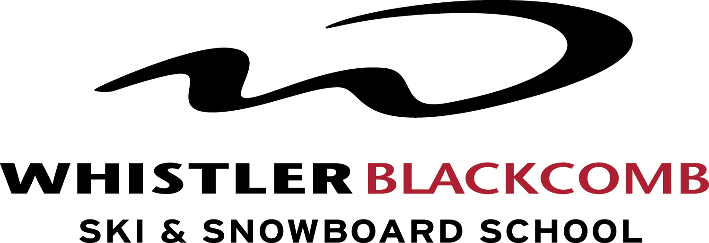

Within our Adult Snow School Programs, Daily Max 4 Lessons are 10% off during your conference.

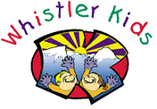
We take having fun seriously. Our children’s instructors are the best of the best – they are patient, caring, encouraging and very supportive every step of the way. All of our group programs include a healthy lunch and snacks as well as access to some of the best facilities in North America. Our Skiing programs range from ages 3-18 and our Snowboarding programs range from ages 4-18 years.

Special 10% discounts have been set up on select children’s programs during your conference.

- Kids and Youth 1-5 day Lessons
- Kids 3-day and 5-day Adventure Camps
- Kids and Youth 5-day Holiday Camps
______________________________________________________________________________________________________________________

Pre-book Equipment Rentals Online & Save Up to 25%

Whistler Blackcomb Rentals are now available via rentskis.com. Group members can select their rentals through this link between March 14, 2019 and March 21, 2019. Simply select Whistler Blackcomb as your location and enter the pick-up and return dates.

See your group’s custom rental link below to reserve your equipment:

https://www.rentskis.com/mskwhistler2019
Please note that pre-booking rates will be paid on-site and only available until March 12, 2019. Once you’re here, there will NOT be an onsite discount option so book EARLY!

